The Moby 5500 provides a smaller, more cost-effective way to accept payments and is optimized for mobility. It uses Bluetooth connectivity with the POS device to accept contactless, inserted, or swiped payments.

### **Contents**

* [Setup](https://revelsystems.lightning.force.com/lightning/r/How_To__kav/ka24X000000gheUQAQ/view#s1)
* [Important Notes](https://revelsystems.lightning.force.com/lightning/r/How_To__kav/ka24X000000gheUQAQ/view#s2)
* [Troubleshooting](https://revelsystems.lightning.force.com/lightning/r/How_To__kav/ka24X000000gheUQAQ/view#s3)

### **Setup**

#### **Charging the Device**

Use the USB-C charging cable included with the reader. The red light will flash if connected to power:

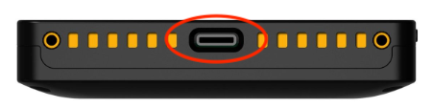

#### **Turning On/Off the Moby 5500**

1. To turn the Moby 5500 on, hold the power button until the indicator lights turns on.

2. To turn the Moby 5500 off, press the side button until the blue indicator light turns off. The red light will flash or stay solid if connected to power.

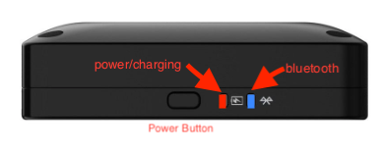

#### **Pairing with iPad**

With the Moby 5500 powered on and the blue indicator light flashing, start the Revel POS App.

If Bluetooth is not enabled, it will prompt to enable Bluetooth on the device. Go to **Settings** to enable:

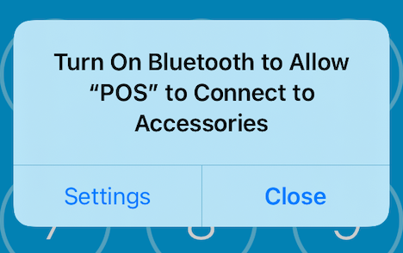

With Bluetooth enabled and the swipe ready to pair, the **POS App Pairing Request** alert will appear. If the device does not prompt after enabling Bluetooth, you may need to stop and restart the app.

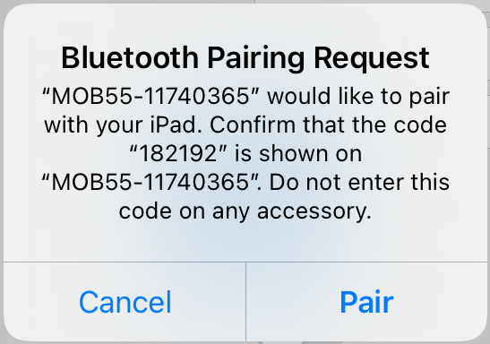

When successfully paired, the swipe will briefly display an LED pattern on the front of the device:



The Bluetooth indicator light should now stay blue on the swipe, indicating that it's paired. The POS app must be running for the device to be paired:



The Bluetooth connection can be confirmed by creating an order and hitting the credit payment button. The app will say **Waiting for Card Input**, and the swipe will have an audible chime.

### **Important Notes**

* When the POS app is exited or minimized, the Bluetooth connection will be lost. The Bluetooth light will flash on the device. The swipe will show as a known device to iOS but will show a **Not Connected** status.
* Navigating back to the POS app or re-starting the POS app should reconnect to the device, and the Bluetooth indicator light on the swipe should turn solid blue.
* If the device is unpaired from the iPad, the swipe will need to be re-booted by holding down the power button in order to re-pair properly.
* **There is a reported 2.75 issue if the POS app is exited or crashes, the swipe must be rebooted or an error will be received when trying to activate the swipe. This issue will be addressed in a future service pack.

### **Troubleshooting**

If the Bluetooth connection is lost:

* If the device is unpaired from the iPad, the swipe will need to be re-booted by holding down the power button in order to re-pair properly.
* Make sure the POS app is in the foreground; this should cause the light to turn solid blue on the swipe.
* If the POS app does not auto reconnect, stop and restart the app.
* If the steps above do not reconnect:
  + Kill the POS app.
  + Go to the iOS Bluetooth settings and select **Forget this Device**.
  + Reboot the swipe by holding the power button down; this can take several seconds.
  + Ensure the swipe Bluetooth light is blinking.
  + Restart the POS app.
  + This should prompt the pair.
* After a successful pairing, the Moby 5500 serial number will be displayed under **My Devices** in iOS **Settings**.